Logarithmic transformations
Code:
import cv2
import numpy as np
image = cv2.imread('cılek.jpg')
if image is None:
exit()
gray_image = cv2.cvtColor(image, cv2.COLOR_BGR2GRAY)
gray_image = np.float32(gray_image)
c = 255 / np.log(1 + np.max(gray_image))
log_image = c * np.log(1 + gray_image)
log_image = np.array(log_image, dtype=np.uint8)
cv2.imshow('Original Image', image)
cv2.imshow('Logarithmic Transformation', log_image)
cv2.waitKey(0)
cv2.destroyAllWindows()
Code Explanation:
- The image 'cılek.jpg' is loaded using cv2.imread().
- The image is converted to grayscale using cv2.cvtColor() to simplify the processing.
- The grayscale image is converted to float32 to avoid issues during the logarithmic transformation.
- A logarithmic transformation is applied to the grayscale image using the formula c×log⁡(1+image)c \times \log(1 + \text{image})c×log(1+image), where ccc is a scaling factor calculated based on the maximum pixel value.
- The resulting transformed image is converted back to uint8 for proper display.
- The original and transformed images are displayed using cv2.imshow().

Output:

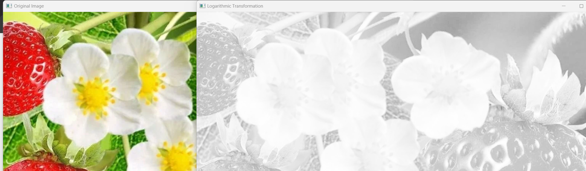

Report:
This code applies a logarithmic transformation to an image to enhance its contrast, especially in dark regions. The transformation is commonly used in image processing to compress the dynamic range of an image, making details in the darker areas more visible.
The image is first converted to grayscale, then a logarithmic function is applied to enhance the contrast. The result is a more pronounced differentiation in the lower intensity regions, which is often useful for images with high dynamic range or images that are too dark.
The logarithmic transformation is defined as:
Inew=c×log⁡(1+Iold)I_{\text{new}} = c \times \log(1 + I_{\text{old}})Inew​=c×log(1+Iold​)
where ccc is a scaling constant and IoldI_{\text{old}}Iold​ and InewI_{\text{new}}Inew​ are the original and transformed pixel intensities, respectively.
After the transformation, the image is converted back to the uint8 format and displayed alongside the original for comparison.

